Arab Advisors Group

Amman
Tel 962.6.5681608
Fax 962.6. 5681530
PO Box 2374, Amman 11821
Jordan

For more information
www.arabadvisors.com
arabadvisors@arabadvisors.com

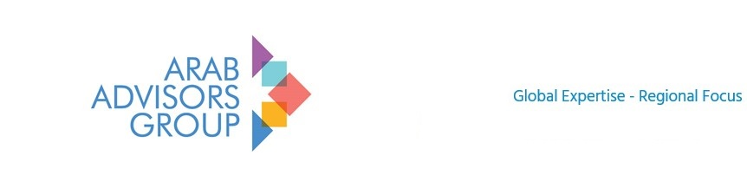
FOR IMMEDIATE RELEASE

News Release – March 23, 2023

Media Contact: Rula Jabr
+962.6.5681608
rula.jabr@arabadvisors.com
Arab Advisors Group is Launching a consumer panel in Iraq during Ramadan 2023
Arab Advisors Group is launching a consumer panel in Iraq. The panel will target a representative sample of Iraqi consumers. WE will examine consumer behavior and the relationship with TV media consumption during the holy month of Ramadan.

Arab Advisors Group is pleased to announce the launch of a consumer panel in Iraq. The inauguration of this panel examines consumer behavior and the relationship with TV media consumption during the holy month of Ramadan. The panel is built with a representative sample of Iraqi consumers in Baghdad, Basra, Erbil and Mosul.

Arab Advisors Group is delighted to provide custom consumer market research in a market which has been a long-standing market of interest to our clients in telecoms, media and IT since 2001. The Iraqi market has certainly established itself as one of the key markets of MENA.

Arab Advisors Group will be sharing research excerpts of findings throughout the holy month. Keep an eye out for daily interesting panel findings published on our Facebook, LinkedIn, and Twitter pages. We can also add you to our mailing list if you email us.

Contact us for full details on our market research and custom consultancy capabilities.
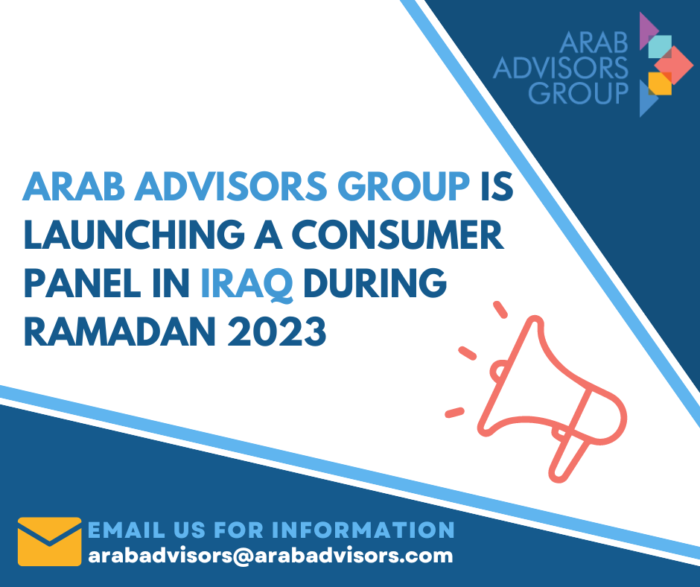
Arab Advisors Group’s team of analysts in the region produced over 5,800 reports on the Arab World’s communications, media and financial markets. The reports can be purchased individually or received through an annual subscription to Arab Advisors Group’s (www.arabadvisors.com) Strategic Research Services (Media and Telecom).

To date, Arab Advisors Group serves over 965 global and regional companies by providing reliable research analysis and forecasts of Arab communications markets to these clients. Some of our clients can be viewed on https://arabadvisors.com/client-list

-END-

Special note to the editors: Kindly use Arab Advisors (not AAG) when abbreviating Arab Advisors Group. AAG is not a suitable abbreviation since it conflicts with the name of another company not related at all to Arab Advisors Group.

Arab Advisors Group’s Arabic name is مجموعة المرشدين العرب
Please include our name in English in brackets after the name in Arabic

Arab Advisors Group provides reliable research, analysis and forecasts of Arab communications, media and technology markets.

The services cover nineteen countries in the Arab World: Lebanon, Syria, Jordan, Palestine, Iraq, Egypt, Sudan, Saudi Arabia, Yemen, UAE, Kuwait, Qatar, Bahrain, Oman, Libya, Tunisia, Algeria, Morocco and Mauritania.
For more information, please contact Arab Advisors Group offices. www.arabadvisors.com

